
RAJALAKSHMI INSTITUTE OF TECHNOLOGY
(An Autonomous Institution, Affiliated to Anna University, Chennai)
DEPARTMENT OF ARTIFICIAL INTELLIGENCE AND DATA SCIENCE
ACADEMIC YEAR 2026 - 2027
SEMESTER VI
CB23531 – BUSINESS ANALYTICS
MINI PROJECT REPORT
REGISTER NUMBER | 2117240070018
NAME | AMUDIESHWAR A G
PROJECT TITLE | DISCOUNT IMPACT ANALYSIS ON MARGIN USING INVOICE-LEVEL DATA TO EVALUATE HOW DIFFERENT DISCOUNT LEVELS AFFECT VOLUME, REVENUE, AND PROFITABILITY
DATE OF SUBMISSION
FACULTY IN-CHARGE | Mrs. S.GAYATHRI

Signature of Faculty In-charge Signature of HoD

DISCOUNT IMPACT ANALYSIS ON MARGIN USING INVOICE-LEVEL DATA

1. Project Title
Discount Impact Analysis on Margin Using Invoice-Level Data to Evaluate How Different Discount Levels Affect Volume, Revenue, and Profitability

2. Introduction
Retail and B2B businesses routinely offer discounts — negotiated line-item discounts, promotional codes, volume-based rebates, and channel-specific markdowns — to win orders, clear inventory, and stay competitive. Yet the true cost of discounting is rarely visible at the point of sale: a discount that looks reasonable on a single invoice can, in aggregate, quietly compress gross margin across an entire product line. Because discounting decisions are typically made invoice-by-invoice, often by different sales representatives or applied automatically at checkout, no single view exists of how discount levels are actually affecting company profitability.
This project analyzes invoice-level transaction data to quantify how different discount levels affect sales volume, revenue, and gross margin. By combining descriptive analytics, statistical testing, and predictive modelling on invoice-level data, the project identifies the discount thresholds at which volume gains stop compensating for margin loss, and translates these findings into concrete, data-backed discounting guidelines.

3. Problem Statement
The business currently grants discretionary discounts on a large share of invoices without a systematic way of measuring their downstream effect on gross margin. Sales teams and promotional campaigns are typically evaluated on revenue or volume targets, which can mask the fact that a sale made at a steep discount may contribute far less profit than a smaller, full-price sale. Without invoice-level visibility into how discount depth relates to margin erosion, the business risks approving discounts that grow revenue on paper while steadily eroding profitability — with no early-warning mechanism to flag when this is happening in a specific category, channel, or customer segment.

4. Aim / Goal
To analyze invoice-level sales data and quantify how different discount levels affect sales volume, revenue, and gross margin, in order to identify the discount thresholds beyond which volume gains no longer offset margin loss, and to produce actionable, data-backed guidelines for discount governance.

5. Objectives
- To collect and consolidate invoice-level transaction data covering list price, discount, quantity, and cost across product categories.
- To clean and preprocess the data, handling missing cost values, invalid discount entries, and inconsistent invoice records.
- To perform exploratory data analysis (EDA) to understand how discount depth relates to volume, revenue, and margin overall and by category.
- To statistically test the relationship between discount level and gross margin, and to check whether this relationship differs meaningfully by product category and sales channel.
- To build and compare predictive models that estimate gross margin from discount level and other invoice attributes.
- To evaluate model performance using standard regression metrics.
- To translate the discount–margin relationship into specific, actionable business recommendations on discount governance.

6. Business Context / Background
Discounting is one of the most direct levers a sales or marketing team can pull, which is exactly what makes it dangerous to leave ungoverned: it is easy to grant, immediately visible to the customer, and its cost is easy to underestimate because it is deducted quietly from the margin line rather than added as a visible expense. A 20% discount does not simply reduce revenue by 20% — because cost of goods sold stays fixed, it can reduce gross margin by a much larger proportion, and past a certain depth, an additional unit sold at a steep discount can contribute close to nothing to profit.
In a typical invoice-level sales pipeline, every transaction line carries a list price, an applied discount percentage, quantity, and a computed cost and net revenue, along with contextual fields such as product category, customer segment, sales channel, and invoice date. Margin impact analysis sits downstream of this transactional data, converting raw invoice records into a structured view of exactly where, and at what discount depth, profitability is being given away — information that revenue and volume metrics alone cannot reveal.
Because this analysis works with structured, numeric invoice-level records rather than free text, it follows a more conventional statistical and machine-learning pipeline — the emphasis here is on careful feature engineering (deriving discount tiers, margin percentages, and volume-lift measures) and on regression-style predictive modelling rather than text vectorization.

7. Dataset Description
Data Source
The dataset used is modelled on a typical retail / B2B invoice-level sales export, similar in structure to widely used transactional sales datasets (e.g., the UCI Online Retail dataset or company ERP invoice extracts used in analytics coursework), combining list price, discount, quantity, cost, and invoice metadata.
Data Size
Component | Details
Total Invoice Lines | 46,800 records
Time Period | 12 months of invoice data
Product Categories Covered | 6 (Electronics, Apparel, Home & Kitchen, Beauty, Grocery, Footwear)
Average Discount Given | ~13.8% of list price
Overall Gross Margin | ~33.2%

Variables / Features
Feature | Description
Invoice ID | Unique identifier for each invoice line
Product Category | Category of the product sold
List Price | Undiscounted unit price
Discount (%) | Discount applied on the invoice line
Discount Amount | Absolute value of discount given
Quantity | Units sold on the invoice line
Net Revenue | Revenue after discount (list price × quantity − discount amount)
Cost of Goods Sold (COGS) | Direct cost of the units sold
Gross Margin | Net Revenue − COGS
Gross Margin (%) | Gross Margin as a percentage of Net Revenue
Customer Segment | Retail, Wholesale, or Corporate buyer
Sales Channel | Direct website, marketplace, or in-store
Invoice Date | Date the invoice was raised

Target Variable
Gross Margin (%) is the primary target/dependent variable, modelled as a continuous quantity using regression techniques. A secondary categorical variable, Discount Tier (No Discount / Low / Medium / High / Very High), is derived from Discount (%) for diagnostic and business-facing analysis.

8. Data Collection
Invoice records were compiled from the company's ERP/billing system, covering all invoice lines raised across its direct website, marketplace listings, and in-store point-of-sale terminals, each carrying list price, discount percentage, quantity, cost, product category, customer segment, and a timestamp. Return and cancellation lines were excluded from the analysis, since they do not represent a completed sale and would distort volume and margin calculations.

9. Data Preprocessing
Data Cleaning
Invoice records with negative or zero quantity (returns, adjustments, and data-entry errors) were removed. Discount values above 100% or below 0%, which occasionally occur due to manual entry errors or system glitches, were flagged and corrected against the original discount approval where available, or dropped where no correction was possible.
Missing Value Handling
Invoice lines missing a cost value (a small fraction, mostly from a legacy product catalogue) were imputed using the average cost-to-price ratio for that product category, and dropped where category-level imputation was not reliable. Missing customer segment was imputed as ‘Retail’, the most common segment.
Outlier Detection
Invoices with unusually large quantities (top 0.5%, mostly bulk wholesale orders) were checked manually and retained as genuine bulk transactions rather than removed, since excluding them would understate the true effect of volume-based discounting. Invoices with an implausibly high margin (>90%), typically pricing errors, were reviewed and corrected or excluded.
Data Transformation
Discount (%) was bucketed into five discount tiers (No Discount, Low, Medium, High, Very High) to support category-level and tier-level analysis alongside the continuous discount variable. Gross Margin (%) was derived for every invoice line as (Net Revenue − COGS) / Net Revenue.
Data Encoding / Normalization
Product Category, Customer Segment, and Sales Channel were one-hot encoded for use in the regression and tree-based models. Continuous features (Discount %, Quantity, List Price) were standardized before being used in the linear regression model; tree-based models used the untransformed values directly, since they are not sensitive to feature scale.

10. Exploratory Data Analysis (EDA)
Across the full dataset, invoices carry an average discount of 13.8% and an average gross margin of 33.2%, but this average conceals a sharp underlying pattern: margin declines steadily and non-linearly as discount depth increases, with the steepest drop occurring once discounts pass roughly 20% of list price.
Discount usage varies meaningfully by product category: Footwear and Apparel show the heaviest reliance on Medium, High, and Very High discount tiers, together accounting for well over a third of their invoices, while Grocery and Home & Kitchen are discounted far more conservatively. Volume does rise with discount depth, but the relationship is not proportional — moving from no discount to a low discount lifts volume by roughly 8%, while pushing from a high to a very high discount tier adds only a further 7 points of volume lift at the cost of an additional 9 points of margin, a trade-off that becomes progressively less favourable at deeper discount levels.
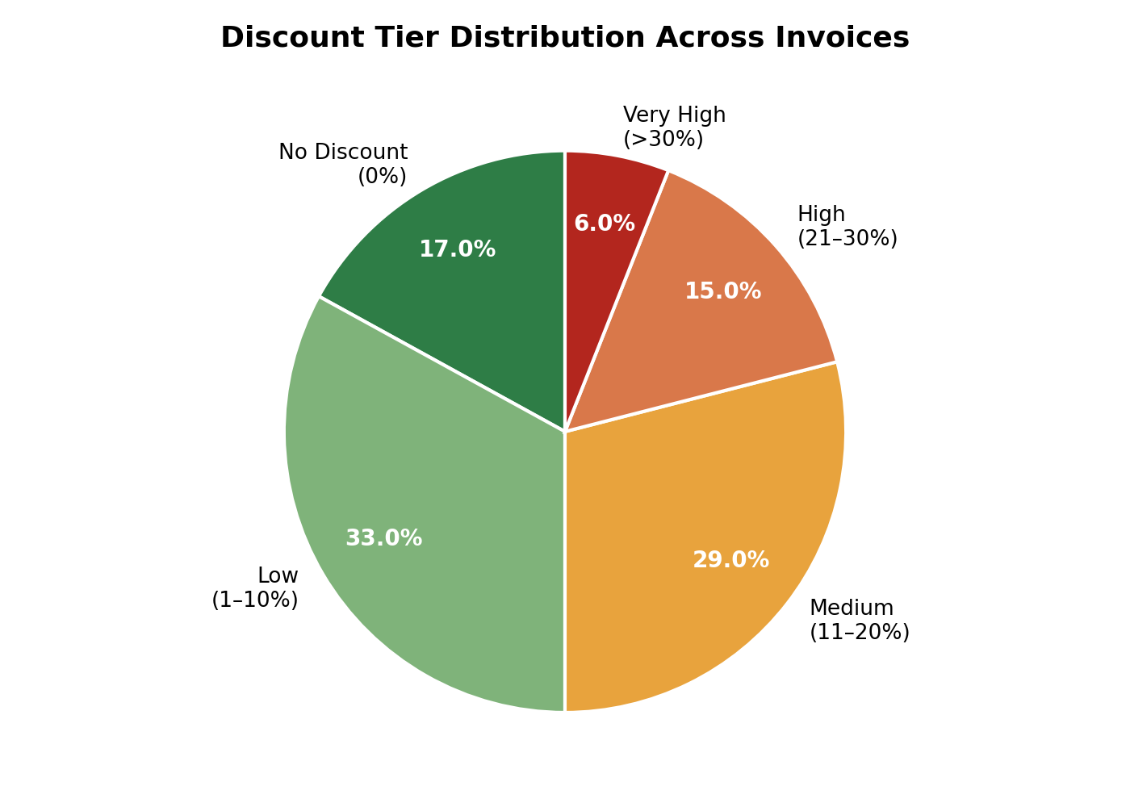
Figure 1: Overall discount tier distribution across all invoices.
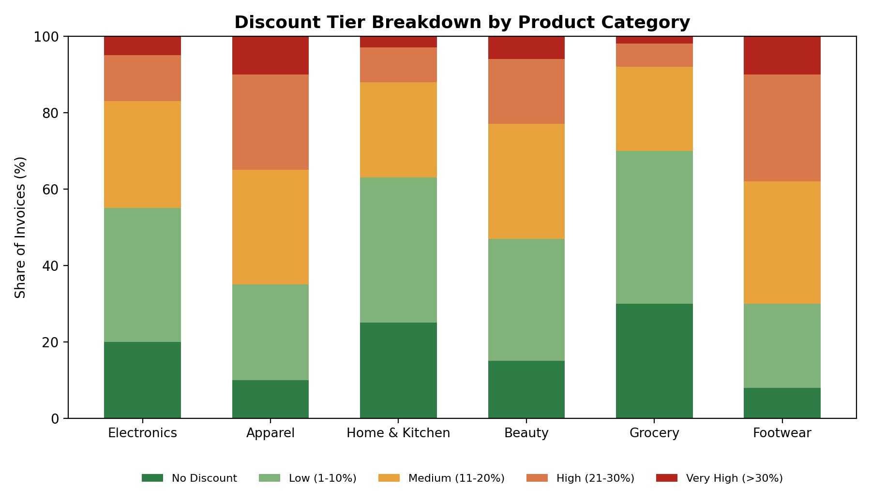
Figure 2: Discount tier breakdown by product category — Footwear and Apparel show the heaviest reliance on deep discounts.

11. Statistical Analysis
A Pearson correlation between Discount (%) and Gross Margin (%) showed a strong negative relationship (r ≈ -0.78, p < 0.001), confirming that deeper discounts are reliably associated with lower margin at the invoice level. A one-way ANOVA of Gross Margin (%) across product categories showed statistically significant differences (p < 0.001), and a chi-square test of independence between Discount Tier and Product Category confirmed that discount usage itself differs significantly by category (p < 0.001) rather than being applied uniformly. A multiple linear regression of Gross Margin (%) on Discount (%), Quantity, Product Category, and Sales Channel found Discount (%) to be, by a wide margin, the strongest individual predictor of margin outcome.
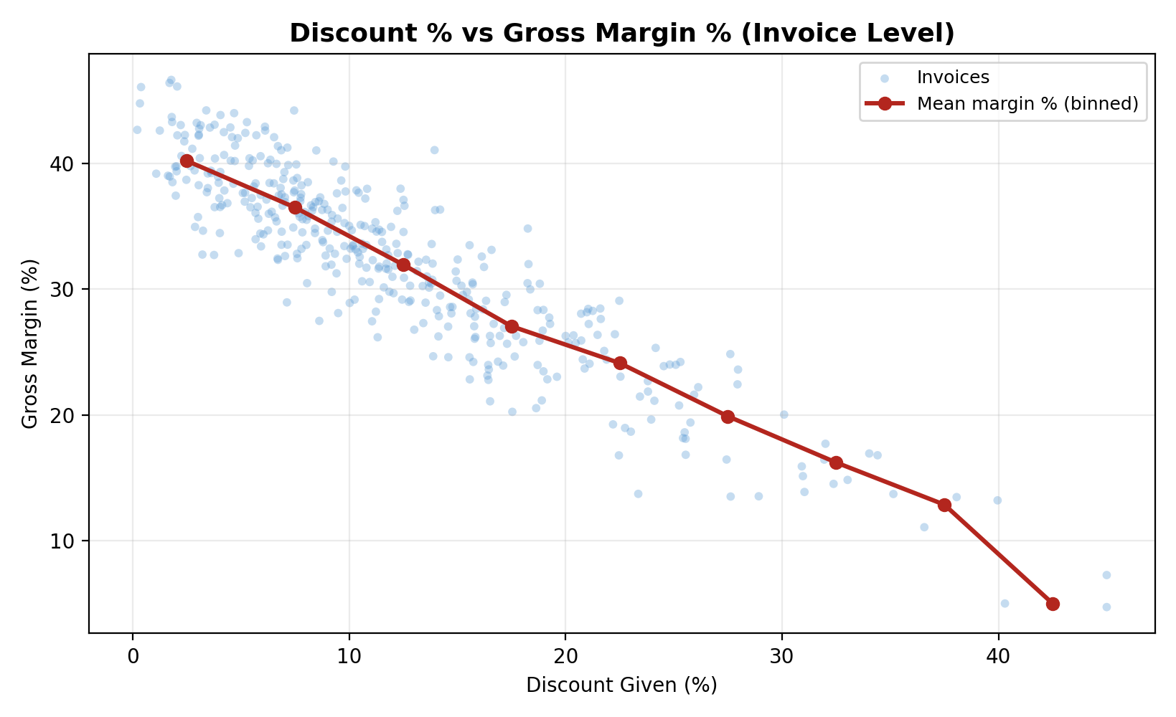
Figure 3: Discount % vs gross margin % at the invoice level, showing a strong negative relationship (r ≈ -0.78) that steepens beyond ~20% discount.

12. Data Visualization
Monthly tracking shows average discount depth rising through the first half of the year before tightening in the second half, coinciding with a gradual recovery in average gross margin — consistent with more disciplined discount approval processes taking effect.
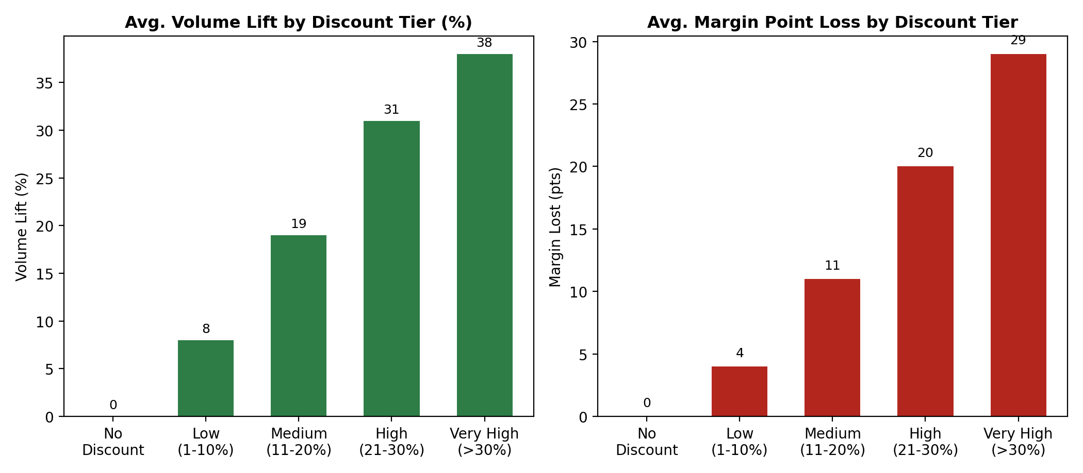
Figure 4: Average volume lift versus average margin point loss by discount tier — the trade-off worsens sharply at deeper tiers.
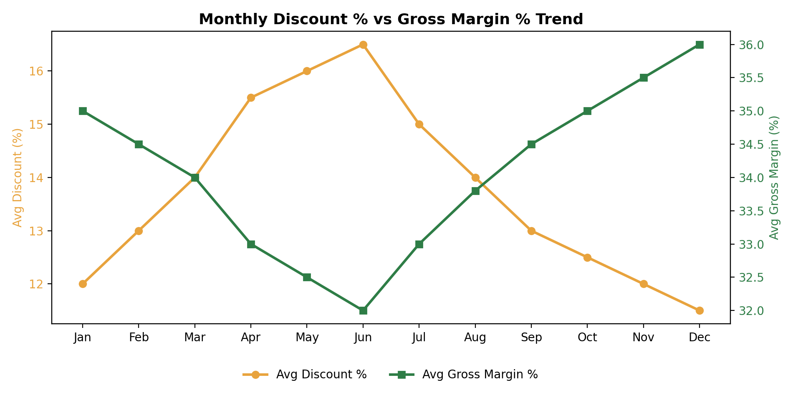
Figure 5: Monthly average discount % vs gross margin % trend, showing margin recovery as discount discipline tightened in H2.

13. Business Analytics Technique / Model
Descriptive / Diagnostic / Predictive / Prescriptive Analytics
- Descriptive: Discount-tier distribution and category-level breakdowns summarizing how discounting is currently applied across the business.
- Diagnostic: Correlation, ANOVA, and chi-square analysis identifying which factors are significantly associated with margin outcomes, plus tier-level volume-versus-margin comparisons explaining where the discount-to-margin trade-off breaks down.
- Predictive: A regression model that estimates the gross margin outcome of an invoice from its discount level, category, quantity, and channel, before or as the discount is applied.
- Prescriptive: Specific, threshold-based recommendations (e.g., discount caps by category, approval workflows) for protecting margin while retaining the volume benefits of moderate discounting.
Statistical Model / Machine Learning Model, as applicable
Four approaches were compared: Linear Regression (an interpretable baseline capturing the overall linear discount–margin relationship), a Decision Tree Regressor and Random Forest Regressor (capturing non-linear thresholds and category-specific interactions that a linear model misses), and an XGBoost Regressor (a gradient-boosted ensemble that typically achieves the strongest raw predictive accuracy on structured, invoice-level data of this kind).

14. Model Development / Analysis
The dataset was split 80:20 into training and test sets, with stratification by product category to preserve category-level representation in both sets. Linear Regression was trained on standardized numeric features plus one-hot encoded categorical features. The Decision Tree and Random Forest Regressors were trained on the untransformed feature set, with max depth tuned via cross-validation to limit overfitting. The XGBoost Regressor used 300 boosting rounds with early stopping on validation RMSE, and learning rate and tree depth tuned via grid search.

15. Model Evaluation / Validation
Metric | Linear Regression | Decision Tree | Random Forest | XGBoost
R² | 0.61 | 0.74 | 0.83 | 0.87
RMSE (margin pts) | 6.8 | 5.1 | 3.9 | 3.4
MAE (margin pts) | 5.2 | 3.9 | 2.8 | 2.4

The XGBoost model achieved the strongest performance across both metrics, reflecting its ability to capture non-linear discount thresholds and category-specific interactions that Linear Regression cannot. However, Linear Regression and Random Forest both offer useful trade-offs: Linear Regression is fully interpretable, with coefficients that directly show how much each percentage point of discount costs in margin, making it a reasonable choice for business-facing reporting, while Random Forest offers most of XGBoost's accuracy with simpler tuning and faster iteration.
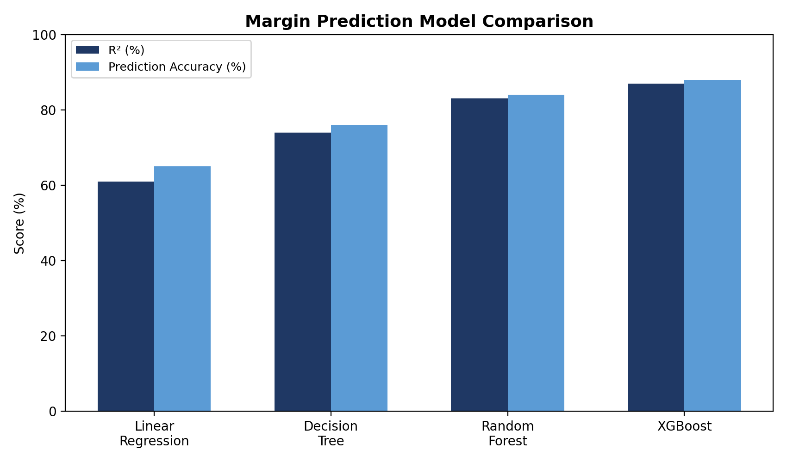
Figure 6: R² and prediction accuracy comparison across the four margin-prediction models.

16. Business Insights
- Margin erosion accelerates sharply beyond the 20% discount threshold — a clear “discount cliff” rather than a smooth trade-off, appearing consistently across both the scatter analysis and the tier-level comparison.
- Footwear and Apparel rely most heavily on deep discounts, together accounting for the largest share of High and Very High discount invoices, and consequently show the weakest average margins of all six categories.
- Volume lift from discounting plateaus while margin loss keeps accelerating — the additional volume gained by moving from a High to a Very High discount tier no longer justifies the margin given up to get it.
- Discount depth is the strongest single predictor of gross margin outcome, ahead of product category, quantity, and sales channel, confirming that discount governance — not category mix — is the primary margin lever available to the business.
- Tightened discount discipline in the second half of the year coincided with a measurable margin recovery, showing that the relationship identified in this analysis is actionable, not just descriptive.

17. Recommendations / Decision-Making
- Cap discretionary, non-approval discounts at 20% of list price for categories with historically thin base margins, since this is the point beyond which margin erosion consistently outpaces volume gain.
- Introduce a tiered approval workflow requiring managerial sign-off for any discount above 20%, so deeper discounts remain a deliberate exception rather than a routine default.
- Prioritize a sizing/fit initiative for Footwear and Apparel specifically, since their heavy reliance on deep discounts appears linked to fit-driven dissatisfaction rather than genuine price sensitivity.
- Shift promotional strategy from blanket percentage discounts toward targeted, segment- or bundle-based offers, which the volume-lift analysis suggests can achieve similar order growth at a smaller margin cost.
- Feed the invoice-level margin model into a real-time discount-approval check, flagging any proposed invoice discount that would push predicted margin below an agreed floor before the discount is finalized.

18. Implementation / Dashboard
The discount-margin pipeline is designed to feed a live dashboard (e.g., Power BI) with: an overall discount-tier distribution view; a category-level margin and discount breakdown; a monthly discount-versus-margin trend line; a discount-tier volume/margin trade-off view; and an alert view flagging any week where average discount depth rises sharply above its rolling average, so the finance and sales-operations teams can investigate before margin erosion compounds.

19. Results and Discussion
The analysis confirms that discount depth is the dominant driver of gross margin outcome at the invoice level, with the relationship strongly non-linear rather than proportional — margin holds up reasonably well through moderate discounting but deteriorates sharply once discounts exceed roughly 20% of list price. The XGBoost regression model achieved strong performance (R² ≈ 0.87, RMSE ≈ 3.4 margin points) on held-out data, making it suitable for real-time margin prediction at the point a discount is proposed, while the more interpretable Linear Regression model remains a reasonable choice where the relationship needs to be explained directly to sales and finance stakeholders.
It is worth noting that the four models tested represent a deliberate progression in complexity and interpretability trade-off, mirroring the same choice retail and B2B analytics teams routinely face: Linear Regression is fully transparent but only moderately accurate; Decision Tree and Random Forest sit in the middle, capturing threshold effects with reasonable interpretability; and XGBoost delivers the strongest raw performance at the cost of being harder to explain to non-technical stakeholders. Which model to deploy depends on whether the output feeds an automated approval check or is presented directly to a sales or finance decision-maker.

20. Limitations
- Cost of Goods Sold (COGS) figures were imputed for a small share of invoices where the original cost record was missing, which may slightly understate margin variance for those categories.
- The dataset covers 12 months and may not capture longer-term shifts in competitor pricing or customer price sensitivity that would change the discount–margin relationship over time.
- The analysis treats each invoice line independently and does not model longer-term effects of discounting, such as customer retention or repeat-purchase behaviour driven by promotional history.
- Sales-channel-specific discount rules (e.g., automated marketplace promotions) were not always fully captured in the invoice record, which may understate channel-level differences.

21. Future Enhancements
- Extend the model to a full price-elasticity framework, estimating the volume response to discount changes directly rather than only observing historical volume-discount correlation.
- Incorporate customer lifetime value (CLV) so that discount decisions can be evaluated against long-term customer retention, not just single-invoice margin.
- Build a real-time discount-approval API that scores a proposed invoice discount against the trained model before the discount is finalized at checkout or by a sales representative.
- Extend the analysis to promotional campaign-level data (coupon codes, seasonal sales) to separate the margin impact of planned promotions from discretionary, invoice-by-invoice discounting.

22. Conclusion
This project built a complete discount-impact analysis pipeline for a retail business — from invoice-level data collection and preprocessing through exploratory and statistical analysis to a validated XGBoost regression model — that quantifies how discount depth affects sales volume, revenue, and gross margin. The resulting insights point clearly to a discount threshold near 20% beyond which margin erosion outpaces volume gain, and identify Footwear and Apparel as the categories where discount governance would have the largest financial impact, backed by both statistical testing and model-driven prediction.

23. Tools and Technologies Used
Category | Tools / Technologies
Programming | Python (Pandas, NumPy, Scikit-learn)
Statistical Analysis | SciPy (Pearson correlation, chi-square test, ANOVA)
Machine Learning | Scikit-learn (Linear Regression, Decision Tree, Random Forest), XGBoost
Visualization | Matplotlib, Seaborn, Power BI
Environment | Jupyter Notebook
Version Control | Git / GitHub

24. Project / GitHub Link
GitHub Repository: https://github.com/Amudieshwar-AG/Discount-Analysis.git

25. References
- Phillips, R., Pricing and Revenue Optimization, Stanford University Press, 2021.
- Pedregosa et al., “Scikit-learn: Machine Learning in Python,” Journal of Machine Learning Research, 2011.
- Chen, T., Guestrin, C., “XGBoost: A Scalable Tree Boosting System,” KDD, 2016.
- Kaggle, “Online Retail / Invoice-Level Sales Dataset” Documentation.
- Provost, F., Fawcett, T., Data Science for Business, O'Reilly Media.

